Regression Test

Introduction:

As part of the quality assurance process, a manual audit has been initiated to validate the results generated by the automated vulnerability scanning tools. Each finding is being reviewed to determine its accuracy and relevance, with the objective of classifying them as either true positives (valid security issues) or false positives (non-exploitable or misidentified issues).
This step ensures the reliability of the final report by eliminating noise from automated tools and confirming the presence and impact of vulnerabilities through manual testing techniques. The scan is done twice a month

Table of Contents
Introduction: 2
Regression Test 4
Executive Summary 4
2025 Q3 Mobile Services Scan 4
Vulnerable Android Version Supported 4
Debug Library Found 4
Component Functionality Not protected 5
Path Traversal 5
XSS in Travel and Expense Report 6
2025 Q3 Manual Scan 7
Alumni 211 Authorization Code Re-Use 7
Alumni 212 Refresh Token are Reusable 7
Alumni 213 Depreciated OAuth Implicit Flow 7
Helpdesk 311 Authorizarion Code reuse in OAuth Flow 2.0 7
Help-desk 312 Refresh Tokens are Reusable 7
Help-desk 313 Access Token Mix Up Vulnerability 8
Help-desk 321 Depreciated OAuth Implicit Flow 8
Helpdesk 322 Cross SIte Scripting 8
Helpdesk 411 Cross SIte Scripting 8
Help-desk 541 SSL certificate Cannot be Trusted 8
Helpdesk 542 Certificate Expiry 9

Regression Test

Executive Summary
The chart below shows the aggregated numbers of issues identified in each category. Solid colored bars represent issues with a confidence level, and the bars fade as the confidence level falls.

2025 Q3 Mobile Services Scan
Description

Vulnerable Android Version Supported

Details :

The application supports the following min and maximum SDK versions

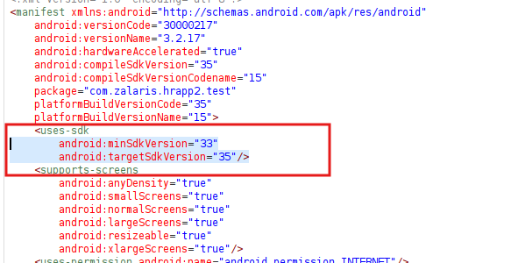

The latest min and max SDK version supported is min=34 and max=35

Still accepted range is min=33 and max=35 - which is set in the application

Issue Found : None

Debug Library Found

Details :

The APK when unzipped - the debug file is not found in the application

Refer screenshot attached below for evidence

Issue Found : None

Component Functionality Not protected

Details :

The application’s activity has been set to true in all the activities that are present.

Refer Screenshot attached below for evidence

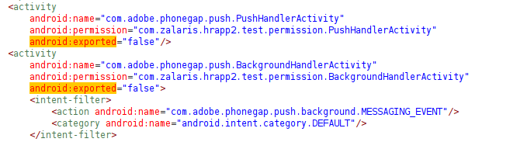

Issue Found : None

Path Traversal

Details :

The application did not encode the URL characters and this led to path traversal

The encoded value is not visible in the ADB and in the application

Tested and the application is not allowing special characters in the filename area . The issue is mitigated in the UI side need to check once via the Proxy request

Refer screenshot attached below for evidence

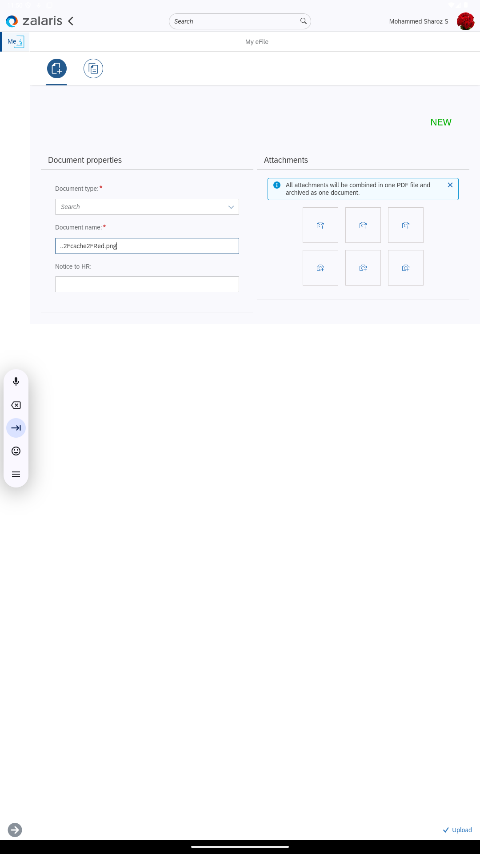

Issue Found : None . path Traversal is fixed

XSS in Travel and Expense Report

Details :

The application did not encode the URL characters and this led to path traversal

The application does not contain My Receipts Tab under Travel and Expense Report

Uploaded File name is accepted but no XSS received

Refer screenshot attached below for evidence

Issue Found : None . path Traversal is fixed

WORKLOG

When | What | Who | Recommended Action
09 February 2026

2025 Q3 Manual Scan
Alumni 211 Authorization Code Re-Use

Details :

The Auth code can be re-used any number of time once obtained

[Issue is accepted by developer ]

The reported issue still exists

Refer screenshot attached below for evidence

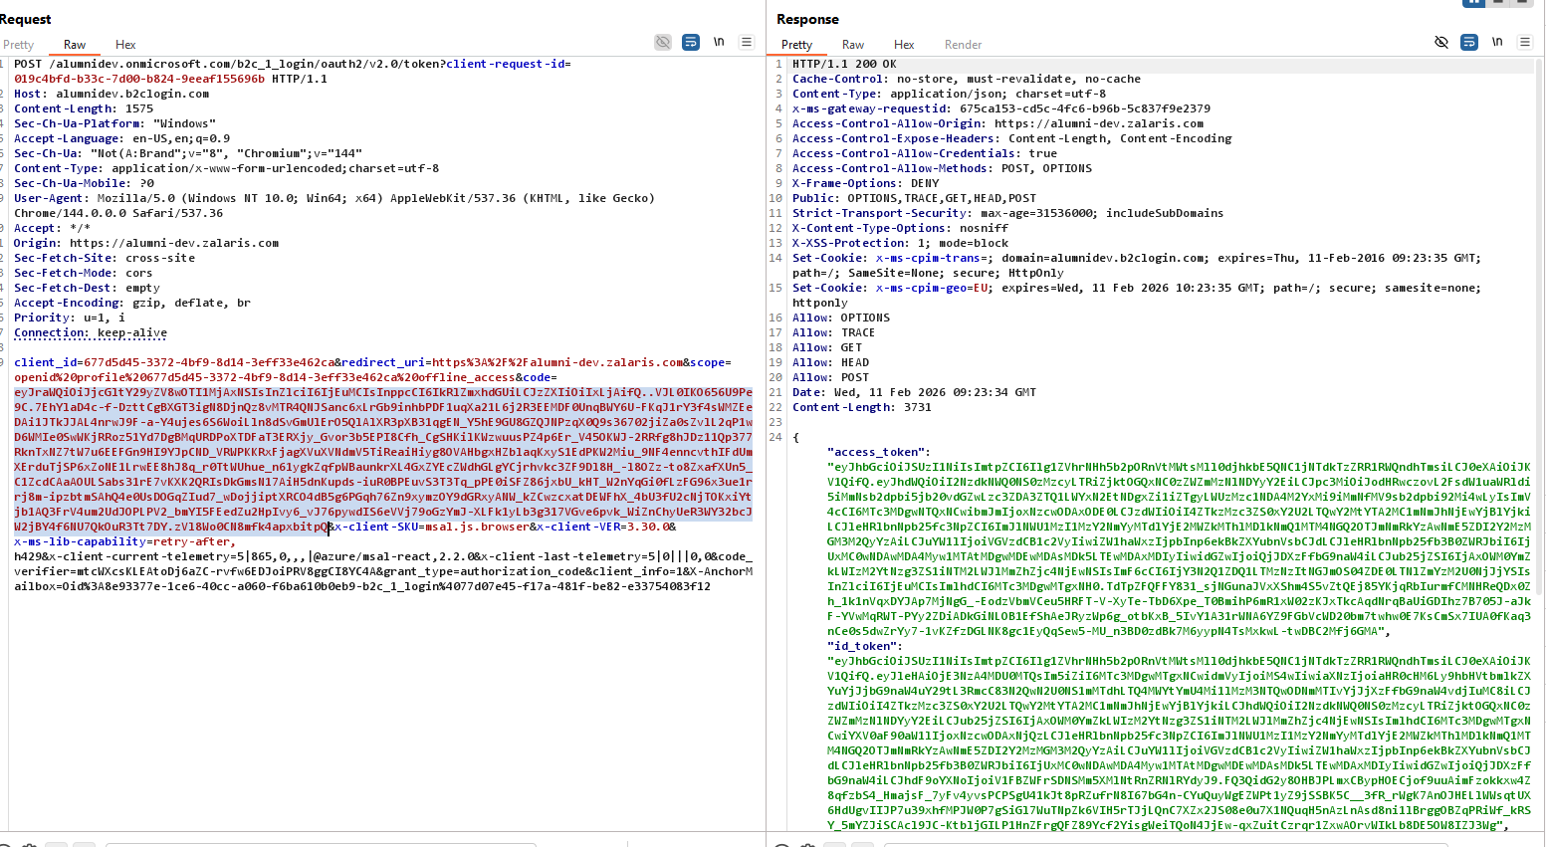

Issue Found : The issue still exists but is accepted by the developer

Alumni 212 Refresh Token are Reusable

Details :

The refresh token received using the authorization code can be used to get the Refresh Token

The Auth Code Request can be modified with the grant type set to refresh token

Refer Screenshot attached below

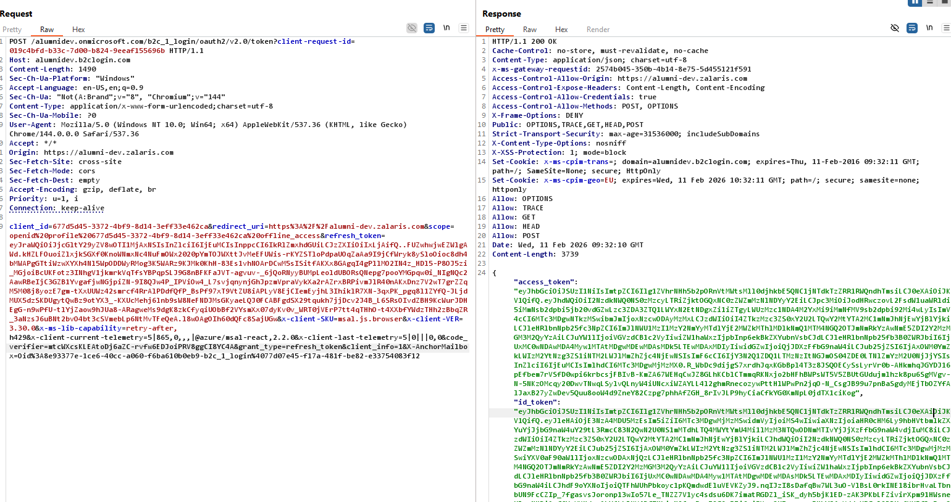

Issue Found : The application allows refresh token can be reused any number of time and is still open.

Alumni 213 Depreciated OAuth Implicit Flow

Details :

Depreciated Implicit flow is supported by the application in the Open-Id Configuration

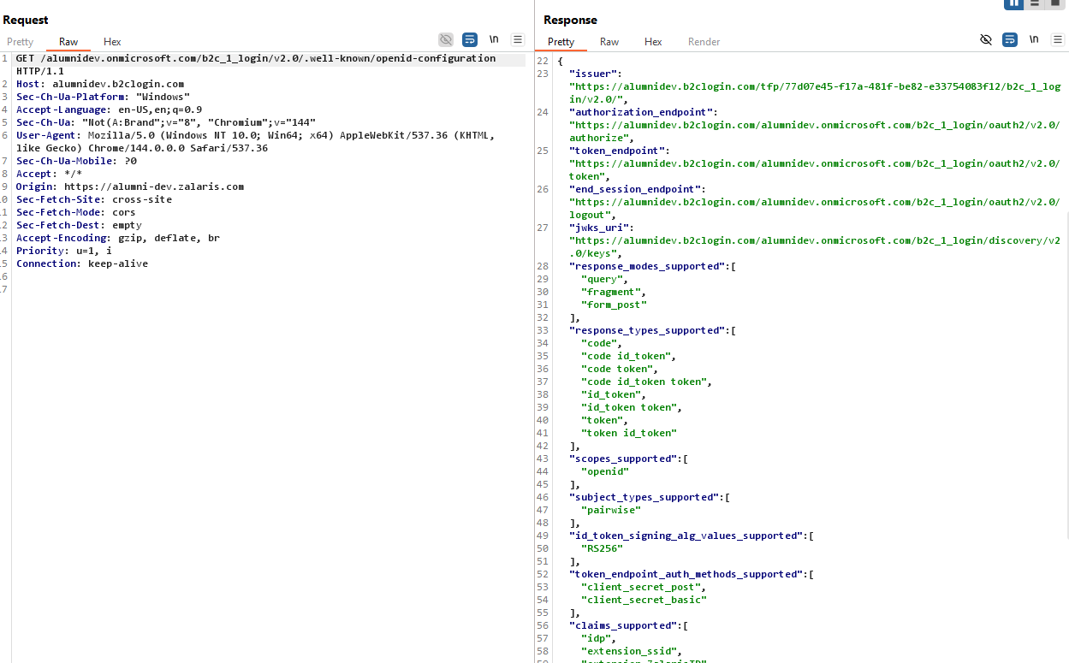

Issue Found : None

Help-desk 311 Authorization Code reuse in OAuth Flow 2.0

Details :

The Auth code can be re-used any number of time once obtained

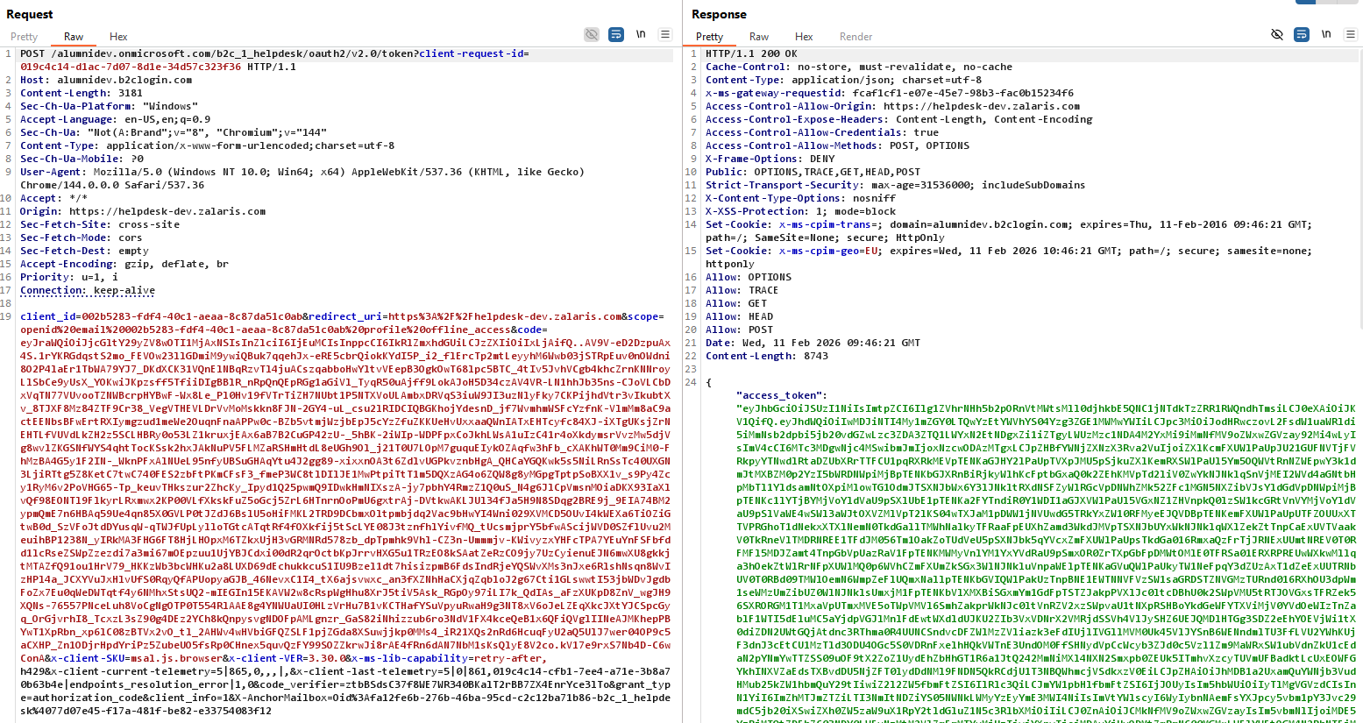

Issue Found : The auth code can be re-used any number of times - the issue still exists

Help-desk 312 Refresh Tokens are Reusable

Details :

The refresh token received using the authorization code can be used to get the Refresh Token

The Auth Code Request can be modified with the grant type set to refresh token

Refer Screenshot attached below

Issue Found : The application allows refresh token can be reused any number of time and is still open.

Help-desk 313 Access Token Mix Up Vulnerability

Details :

The application allows token from one app to be used for another application

When tested application detects the aud and issuer and rejects the response from the server side

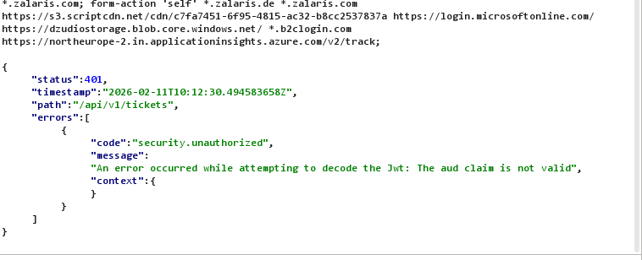

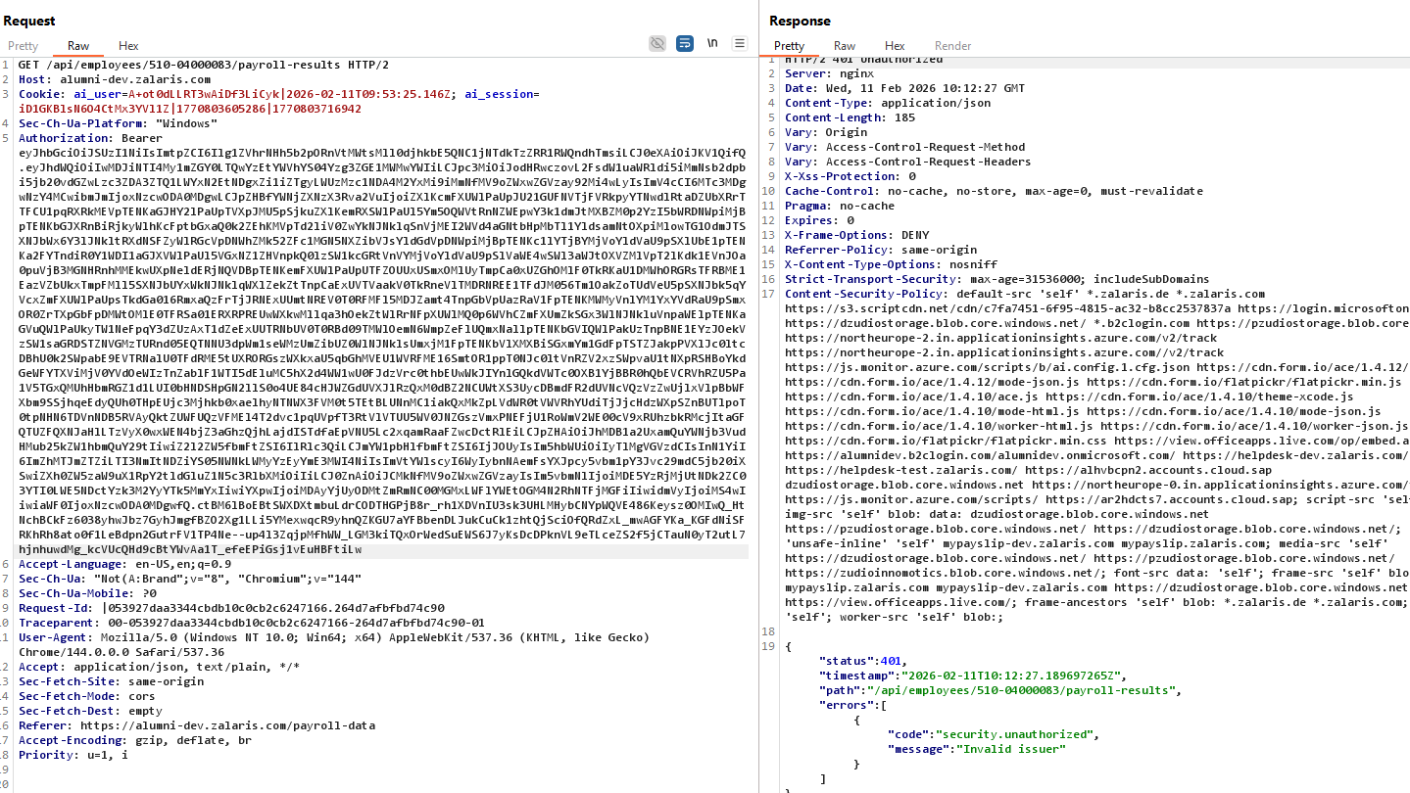

Issue Found : None . The application is detecting the issuer and audience claim and is not allowing Access Token Mix Up Vulnerability

Help-desk 321 Depreciated OAuth Implicit Flow

Details :

The application supports depreciated implicit flow

When re-checked the issue still exists

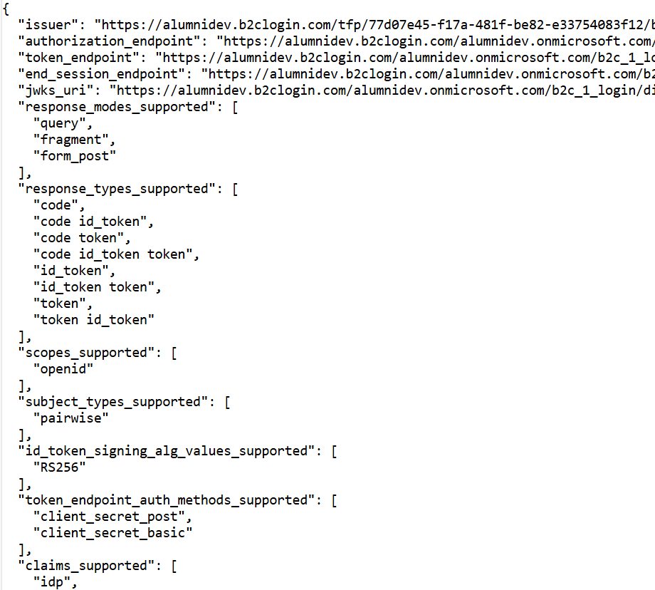

Issue Found : The issue still exists

Helpdesk 322 Cross SIte Scripting

Status : Issue Accepted by Przemek Kubicki

Details :

The application stores the xss payload in the server and backend side but is not executed or reflected

Application Accepts the payload

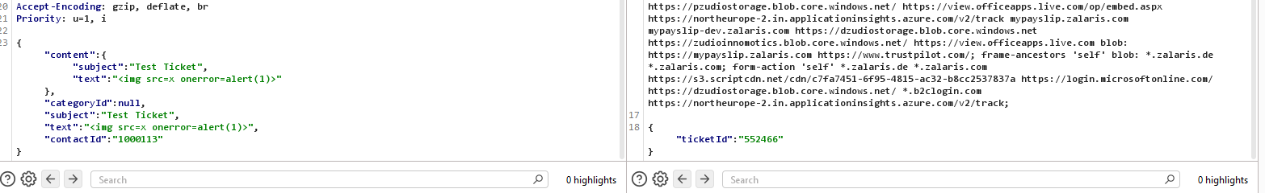

Issue Found : None . path Traversal is fixed

Helpdesk 411 Cross SIte Scripting

Details :

The application did not reflect the stored XSS content from the server side.

My Receipts file was not found.

Refer screenshot attached below for reference.

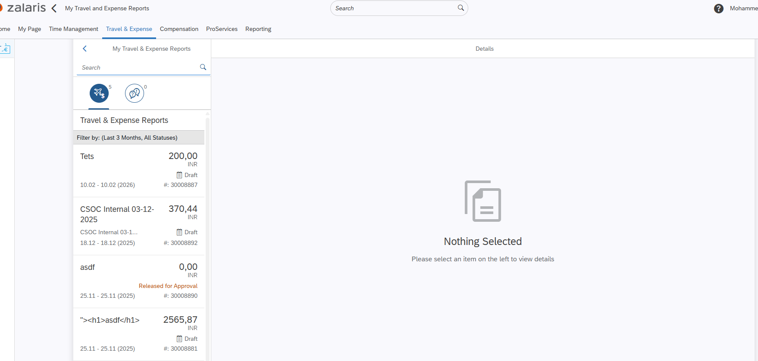

[Create a file with xss filename and upload ]

Issue Found : None .Cross Site Scripting

Help-desk 541 SSL certificate Cannot be Trusted

Details :

When the issue was reported the certificate expired

But when tested on 11-02-2026

The certificate is valid

No chain issues were Detected

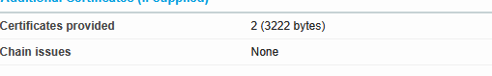

Issue Found : No Issues Found

Helpdesk 542 Certificate Expiry

When the issue was reported the certificate expired

But when tested on 11-02-2026

The certificate is valid

No chain issues were Detected

Issue Found : No Issues Found

WORKLOG

When | What | Who | Recommended Action
09 February 2026

